SIMATS ENGINEERING

ASSESSMENT TOOL 1

COURSE NAME: INTERNET PROGRAMMING COURSE CODE: CSA43

COURSE OUTCOME COVERED

CO-1: Develop well-structured, standards-compliant web pages using HTML/XHTML and XML, and apply Internet protocols and HTTP communication mechanisms for web content delivery. (L2)

Assessment Tool: Application-Based Questions

Weightage: 40%

QUESTIONS: Total Marks: 30

1: Online Symposium Portal

OUTPUT

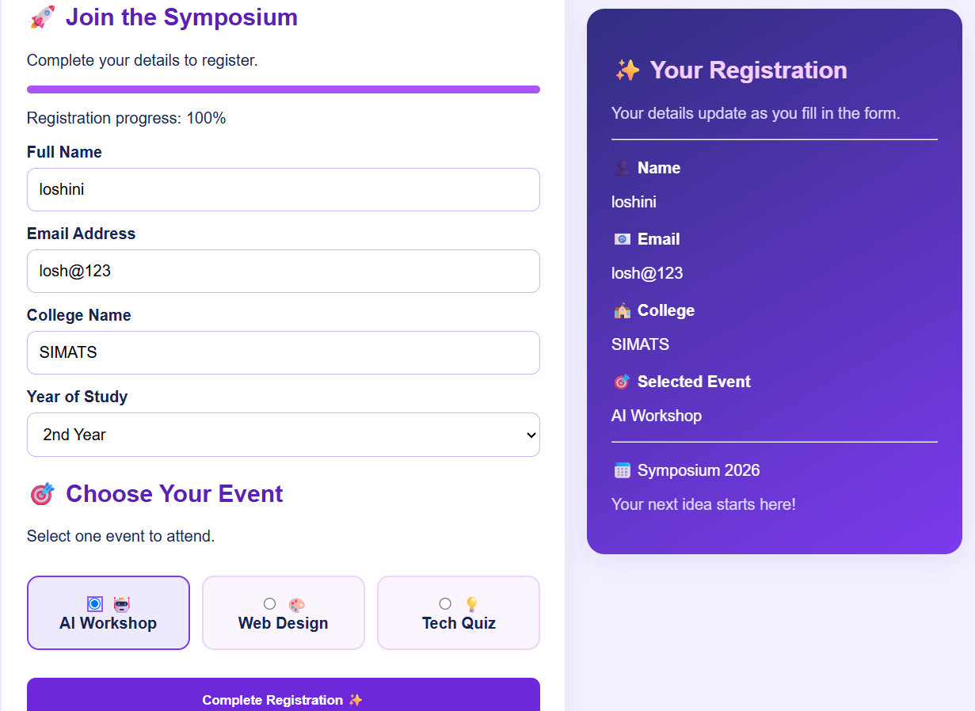
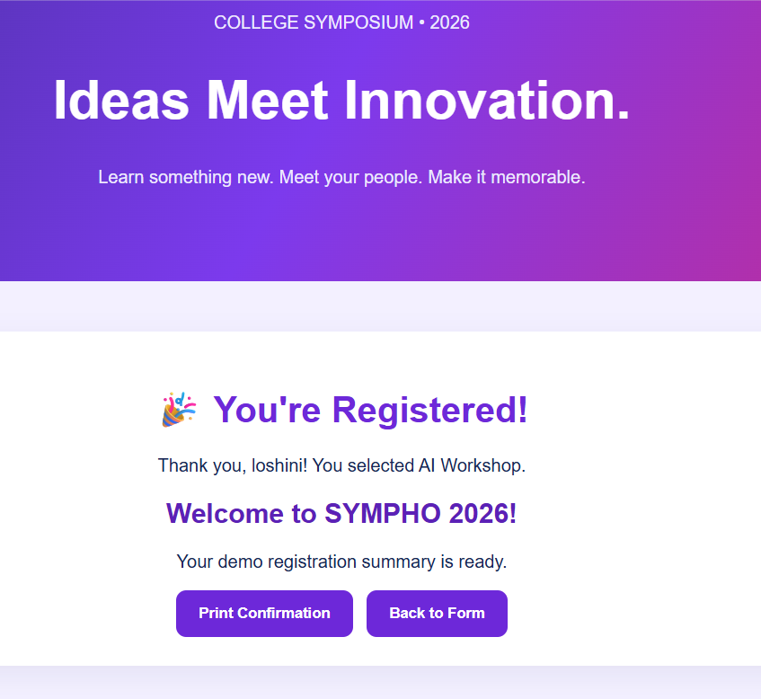

1. Identify appropriate HTML5 semantic elements missing
The original form is missing semantic elements such as:
- <header> – displays the website heading.
- <main> – contains the main content.
- <section> – groups registration details.
- <footer> – displays copyright information.

3. Interpret the HTTP request
When the student submits the form:
- The browser sends a POST request to /register.
- The student's name and email are sent in the request body.
- The server receives and processes the submitted data.

4. Analyze the HTTP response cycle
- The browser sends the HTTP request.
- The server receives and validates the data.
- The server sends an HTTP response with a status code, such as 200 OK.
- The browser processes the response and displays the result.

5. Suggest improvements for usability and accessibility

- Add labels for all input fields.
- Use required to prevent empty submissions.
- Use type="email" for email validation.
- Display clear success and error messages.
- Ensure keyboard accessibility and mobile responsiveness.
- Use HTTPS to protect data during transmission.

2: Cross-Browser Compatibility Issue

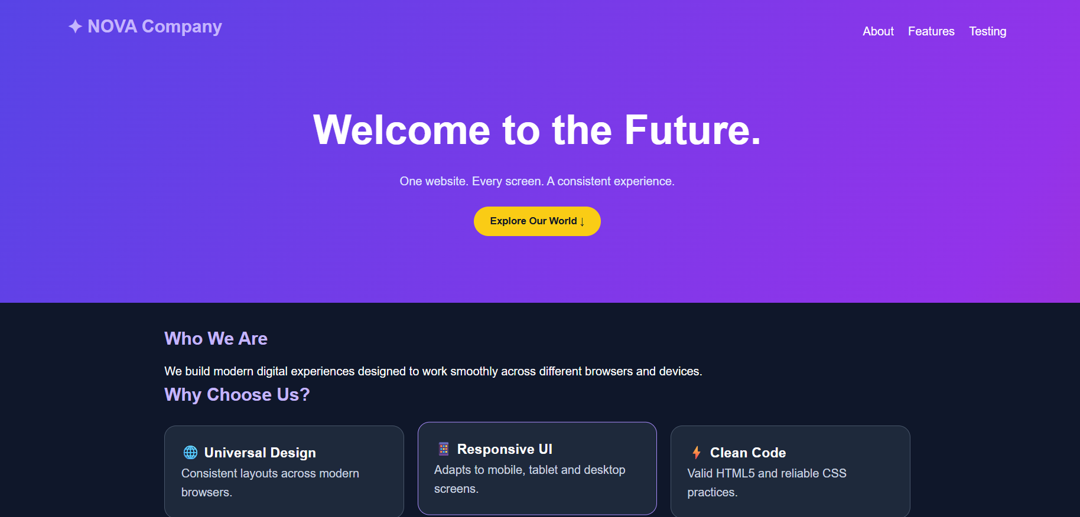

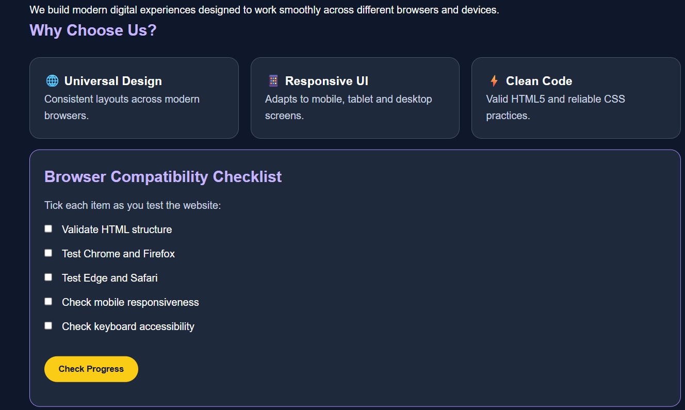

1. Identify improper nesting and missing closing tags

The <h1> tag is missing </h1>.

The <p> tag is missing </p>.

The heading and paragraph are not properly closed before </div>.

2. Analyze how different browsers may interpret this structure

Browsers may automatically correct the missing tags.

Different browsers may interpret the HTML differently, causing inconsistent layout, spacing, and formatting.

3. Identify missing semantic elements

<header> – Defines the page header.

<main> – Defines the main content.

<section> – Groups related content.

<footer> – Defines the page footer.

5. Techniques to ensure cross-browser compatibility

Use valid HTML and CSS.

Close all tags properly.

Include <!DOCTYPE html>.

Use responsive CSS and media queries.

Test the website in Chrome, Firefox, Edge, and Safari.

Validate HTML using the W3C Markup Validation Service.

3: Form Submission Failure

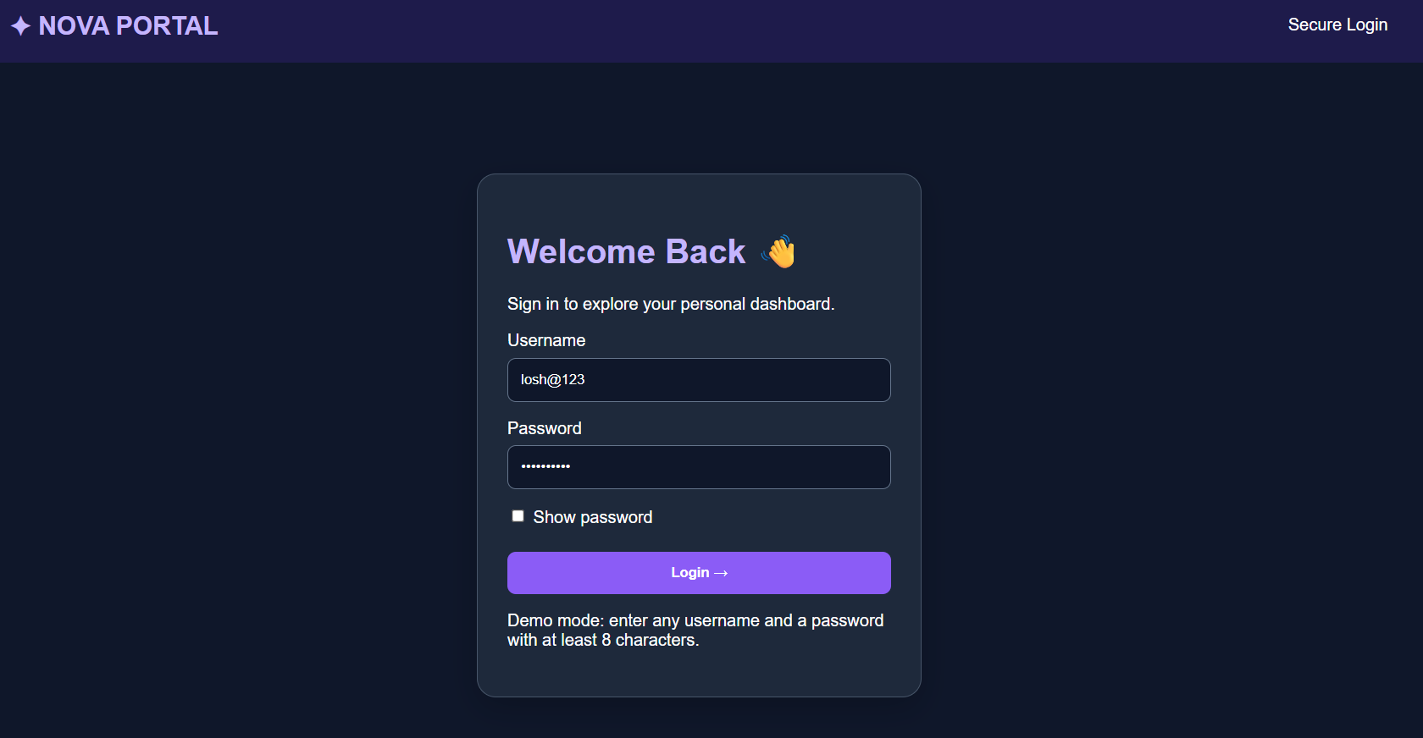



1. Identify issues in the form configuration
- The button uses type="button" instead of type="submit".
- The form has no required validation.
- The GET method is unsuitable for sending passwords because data appears in the URL.
2. Analyze why the HTTP request is not triggered
- type="button" does not submit the form automatically.
- Therefore, clicking Login does not trigger the form's default submission.

3. Interpret the role of GET method
- GET sends form data as URL query parameters.
- It is suitable for retrieving information, such as search results.
- Passwords should not be sent using GET because they can appear in URLs and browser history.
5. Improvements for secure data transmission
- Use HTTPS to encrypt data during transmission.
- Use POST for login form submission.
- Validate inputs on the server.
- Store passwords securely using salted password hashing.
- Use secure session management.
- Never store passwords as plain text.

Code of Conduct:

I LOSHINI,L 192571015 (Name / Reg No) certify that this submission is my original work and that I have adhered to the guidelines specified for this assessment. I understand that any violation of academic integrity rules will result in disciplinary action.

Signature of the student:
LOSHINI,L

Criteria | Weig htage | Level 4 – Exemplary | Level 3 – Proficient | Level 2 – Developing | Level 1 – Beginning
Understanding of Concepts | 25% | Demonstrates thorough, accurate understanding of concepts | Good understanding with minor gaps | Basic understanding with some misconception  s | Poor understandin g; major misconceptio  ns
Explanation | 25% | Detailed, well-explained answers with  relevant examples | Clear explanation with adequate  details | Limited explanation; lacks depth | Poor or unclear explanation
Application | 20% | Effectively applies concepts with strong analytical ability | Applies concepts with minor errors | Limited application with weak  analysis | No application or incorrect  analysis
Organization | 15% | Well-structured answers with logical flow and coherence | Organized with minor issues in flow | Basic structure, lacks clarity | Poor organization, incoherent  answers
Accuracy | 10% | Completely accurate and covers all  required points | Mostly accurate with minor  omissions | Partially correct with  missing points | Incorrect answers with  major gaps
Clarity | 5% | Clear, neat, professional presentation | Understandable with minor issues | Limited clarity, readability issues | Poorly written, difficult to  understand

